**NAAN MUDHALVAN ASSIGNMENT**

NAME : P.DINESH KUMAR

NM ID : au913120104027

1. Create a blog or website using Blogspot . Customize the theme design and post new article with 500 words

# Steps:

**Create a Blogspot account:** Sign up on Blogspot and choose a unique domain name.

**Customize Theme Design:** Access the dashboard, select "Theme" and customize your blog's appearance.

**Write New Article:** Click on "New Post," write a 500-word article, and add relevant images.

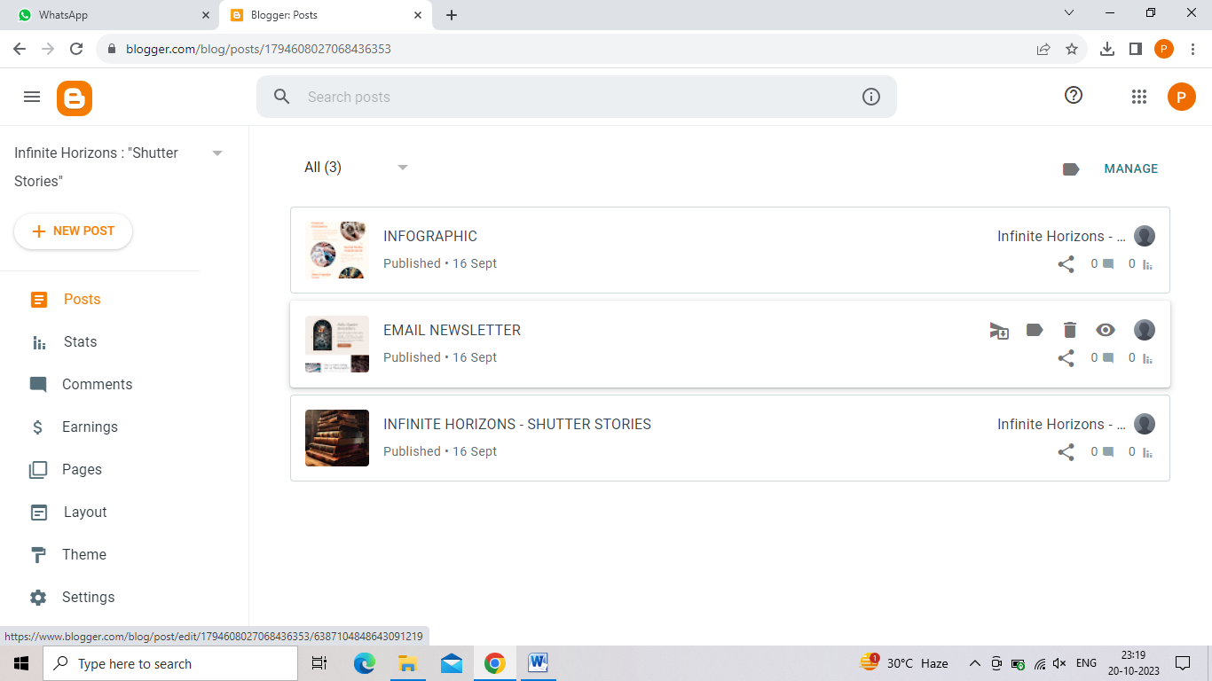**Publish:** Review your post, then click "Publish" to make your article live on your customized Blogspot blog.

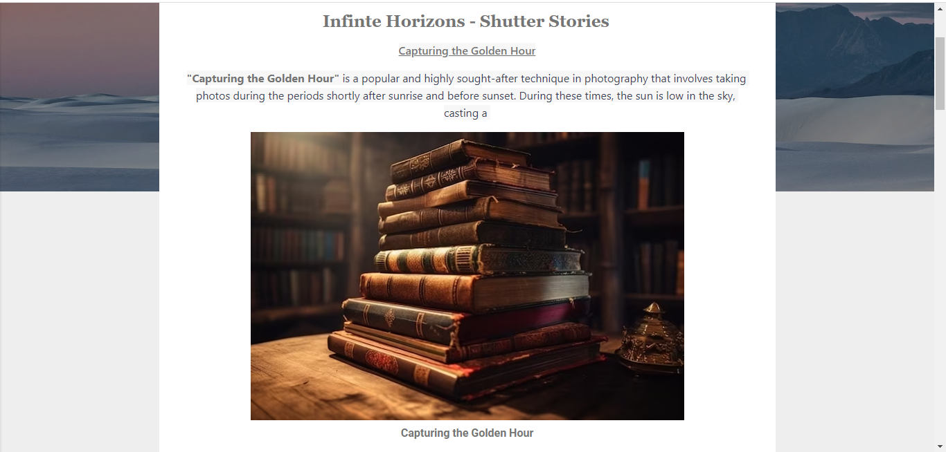

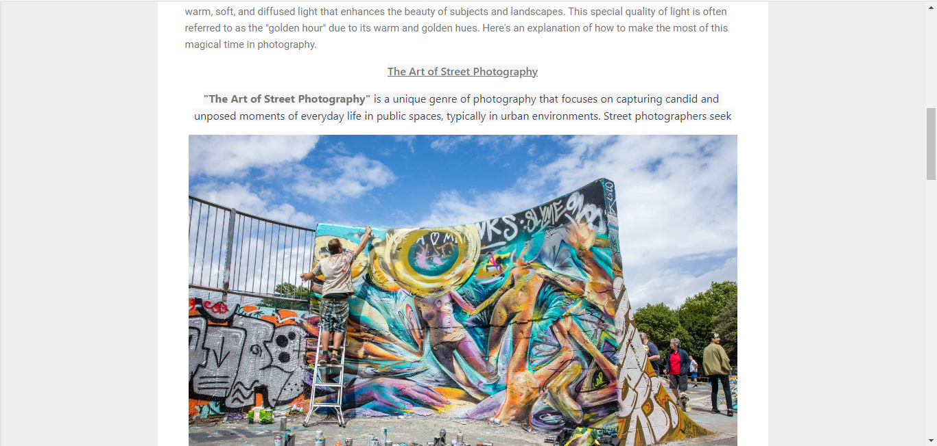

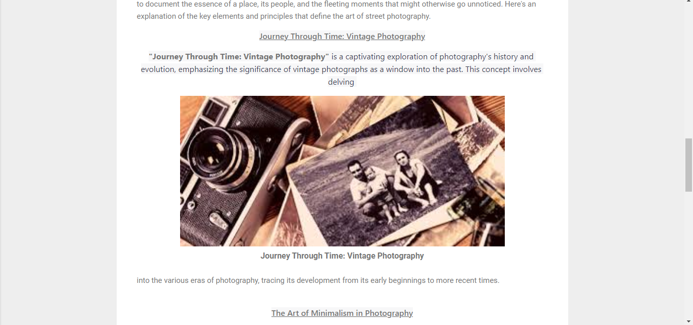

1. Create a New Facebook Business Page and post one social media poster for your brand

# Steps:

**Create a Facebook Business Page:** Go to Facebook and click on "Create" at the top right corner, then select "Page." Choose the type of business and fill in the required details.

**Customize Your Page:** Add a profile picture, cover photo, and business information. Navigate to the "Create" button and select "Post" to create your social media poster. **Design Your Poster:** Use graphic design software or online tools to create a visually appealing poster representing your brand.

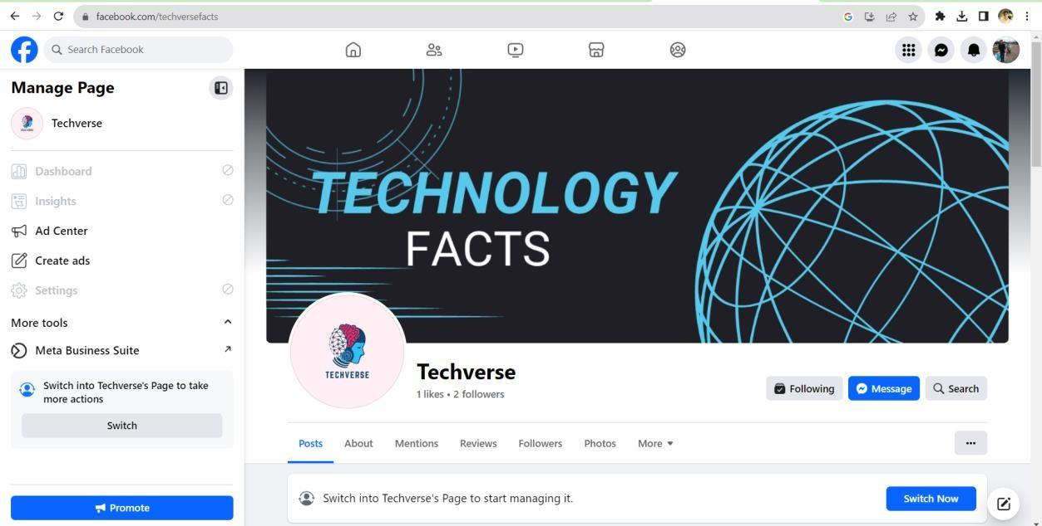**Publish Your Poster:** Upload the poster, add a caption, and click "Publish" to share it on your Facebook Business Page for your audience to see.

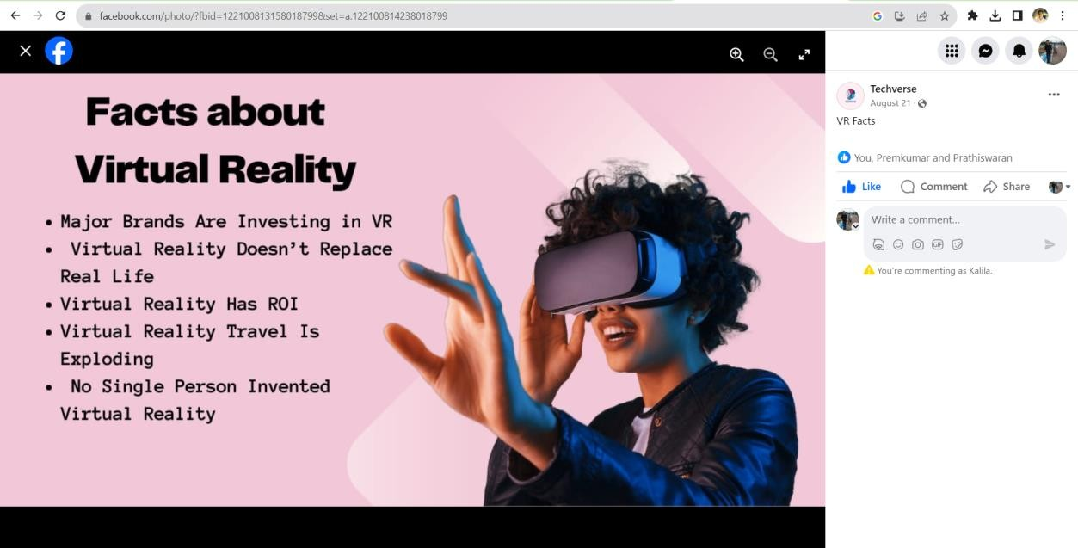

1. Create and design a social media advertisement poster using canva

# Steps:

**Go to Canva:** Visit canva.com and sign in or create an account if you haven't already. **Choose a Template:** Select a social media poster template or start with a blank canvas. Customize the layout, text, images, and colors to match your brand.

**Add Elements:** Drag and drop elements like text boxes, images, icons, and backgrounds onto your canvas. Edit their size, position, and style as desired.

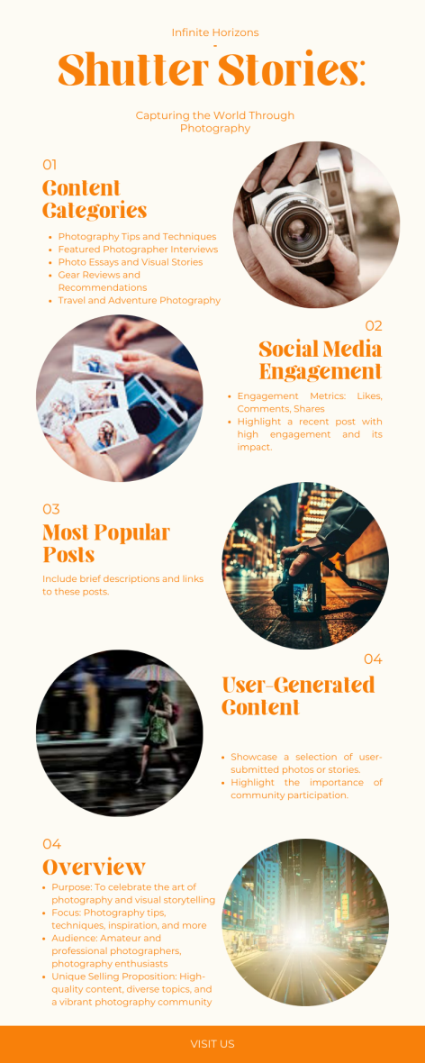 **Download and Publish :** Once your poster is designed, click on the download button and choose the appropriate file format. You can then share your advertisement on social media platforms.

1. Create email newsletter design using MailChimp or canva tool.

**Log In or Sign Up**: Log in to your MailChimp account or sign up for a new one.

**Start a New Campaign:** Click on "Create Campaign" and choose "Email" to begin designing your newsletter.

**Design with MailChimp Editor:** Use MailChimp's intuitive editor to add text, images, and elements. Customize the layout and design to fit your brand.

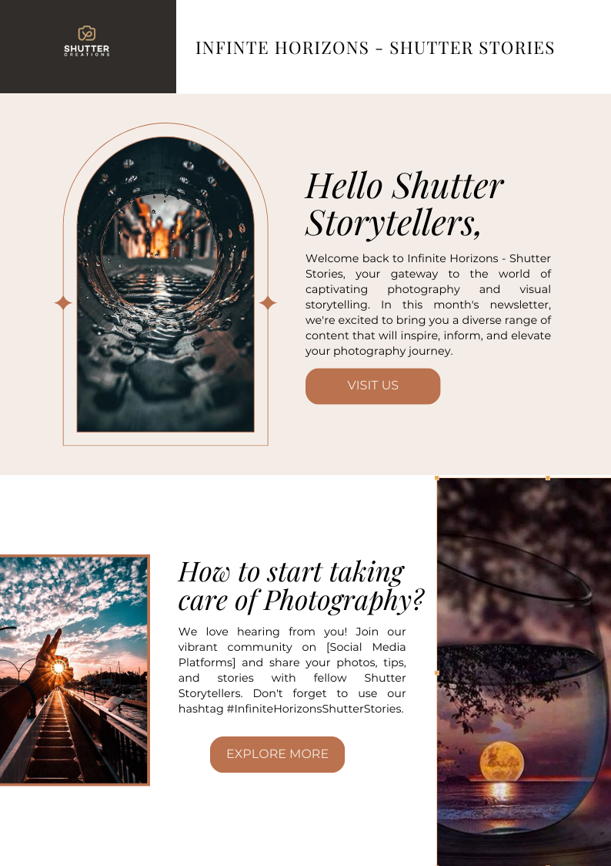**Review and Send:** Preview your newsletter, check for errors, and schedule or send your email to your subscribers.

